C Programming Mini Project

1.Title Page
• Project Title : EVENT MANAGEMENT SYSTEM
•Student Name : MOHAMED ARFIN M
• Register Number : 921724115026
• Department : B.E CSD
• College Name : SETHU INSTITUTE OF TECHNOLOGY
• Course : PROGRAMMING IN C
• Guide / Trainer Name : BALAJI B
• Submission Date : 26-02-2026

2. Abstract
- The Event Management System is a console-based application developed using the C programming language. The main purpose of this project is to simplify the process of planning and managing different types of events such as Birthday, Engagement, Marriage, and custom events. In traditional event booking systems, calculations for catering, hall booking, decoration, photography, and other services are done manually, which may lead to errors and confusion. This program solves that problem by automating the booking and billing process.
- The system allows the user to select the type of event, choose required services such as Mahal (hall), DJ, Makeup, Welcome Girl, Decoration, and Photography, and enter catering details for veg and non-veg plates. Based on the selected options, the program automatically calculates the total cost, applies a 2% discount, and determines the final payable amount after deducting the advance payment. Finally, it generates a detailed bill showing all selected services and their respective charges.
- This project demonstrates the use of basic C programming concepts such as conditional statements, loops, functions, arrays, and user input/output operations. It provides an efficient and user-friendly way to manage event bookings and reduces manual calculation errors.
3. Introduction
- What Problem We Are Solving
In many places, event booking and billing are done manually. Calculating catering, hall rent, DJ, decoration, and other charges by hand can cause mistakes. It also takes more time. This project solves that problem by automatically calculating all costs using a C program.
- Why This Project Is Useful
This project is useful because it:
- Reduces calculation errors
- Saves time
- Automatically generates the total bill
- Calculates discount and remaining balance easilyIt makes event booking simple and accurate
- Where It Can Be Used
This system can be used in:
- Event management companies
- Marriage halls
- Catering services
- Birthday and engagement planning

4. Objectives
- To understand structured programming using C language.
- To use loops and conditional statements in a real project.
- To work with arrays and functions.
- To improve logical thinking and problem-solving skills.
- To develop a simple system for event booking and billing.
5.Tools & Technology
- Programming Language: C
- Compiler: GCC / Turbo C / CodeBlocks
- Platform: Windows / Linux
6. System Requirements
- Hardware Requirements: Basic computer or laptopMinimum 4GB RAMKeyboard andmonitor
- Software Requirements: C Compiler (GCC / Turbo C / Dev C++)Any IDE or Text Editor (Code::Blocks, VS Code, etc.)Windows / Linux Operating System
7. Methodology / Algorithm
- Start the program.
- Show menu.
- Get user details and service choices.
- Calculate total amount.
- Apply discount.
- Show final bill.
- End the program.

8. Flowchart
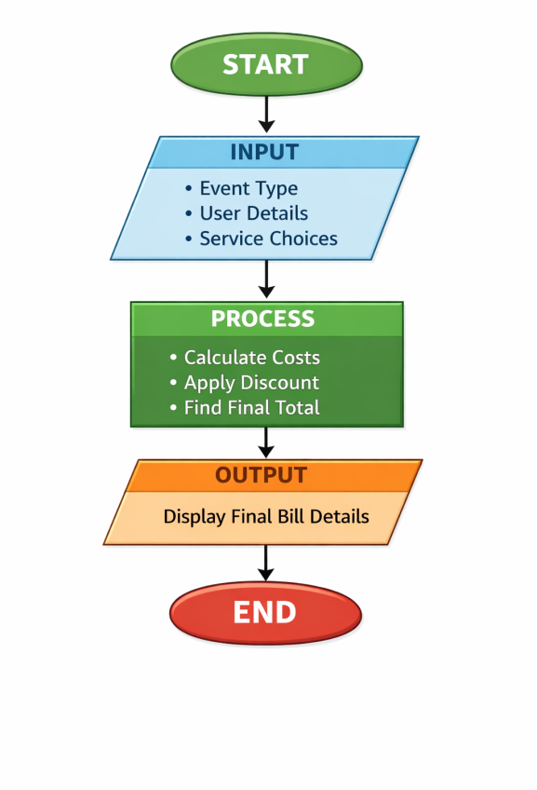

9. Program Code
#include <stdio.h>
#include <string.h>
int main() {
char name[50], address[100], email[50];
char eventName[50];
long long mobile;
int eventChoice;
int totalPersons;
int vegPersons, nonVegPersons;
int mahalChoice, mahalType;
int djChoice, makeupChoice, welcomeChoice;
int decorationChoice;
int photoChoice, photoDays;
float mahalAmount = 0, djAmount = 0, makeupAmount = 0;
float welcomeAmount = 0, decoAmount = 0, photoAmount = 0;
float vegAmount = 0, nonVegAmount = 0;
float total, discount, finalAmount;
float advanceAmount, remainingAmount;

printf("============= EVENT MANAGEMENT SYSTEM ============\n");

printf("\nEnter Name: ");
scanf(" %[^\n]", name);

printf("Enter Mobile Number: ");
scanf("%lld", &mobile);

printf("Enter Address: ");
scanf(" %[^\n]", address);

printf("Enter Email ID: ");
scanf(" %[^\n]", email);

printf("\nSelect Function Type:\n");
printf("1. Birthday\n");
printf("2. Engagement\n");
printf("3. Marriage\n");
printf("4. Your Choice\n");
printf("Enter Choice: ");
scanf("%d", &eventChoice);

if(eventChoice == 1)
strcpy(eventName, "Birthday");
else if(eventChoice == 2)
strcpy(eventName, "Engagement");
else if(eventChoice == 3)
strcpy(eventName, "Marriage");
else {
printf("Enter Your Event Name: ");
scanf(" %[^\n]", eventName);
}

printf("\nMahal Required? (1-Yes / 0-No): ");
scanf("%d", &mahalChoice);

if(mahalChoice == 1) {
printf("Select Mahal Type:\n");
printf("1. 250 Persons - Rs.25000\n");
printf("2. 500 Persons - Rs.60000\n");
printf("3. 1500 Persons - Rs.120000\n");
printf("Enter Choice: ");
scanf("%d", &mahalType);

if(mahalType == 1)
mahalAmount = 25000;
else if(mahalType == 2)
mahalAmount = 60000;
else if(mahalType == 3)
mahalAmount = 120000;
}
printf("\nEnter Total Number of Persons: ");
scanf("%d", &totalPersons);

printf("\nEnter Number of Veg Plates: ");
scanf("%d", &vegPersons);

printf("Enter Number of Non-Veg Plates: ");
scanf("%d", &nonVegPersons);

vegAmount = vegPersons * 200;
nonVegAmount = nonVegPersons * 300;

printf("\nDJ Required? (1-Yes / 0-No): ");
scanf("%d", &djChoice);
if(djChoice == 1)
djAmount = 25000;

// Makeup
printf("Makeup Required? (1-Yes / 0-No): ");
scanf("%d", &makeupChoice);
if(makeupChoice == 1)
makeupAmount = 20000;

printf("Welcome Girl Required? (1-Yes / 0-No): ");
scanf("%d", &welcomeChoice);
if(welcomeChoice == 1)
welcomeAmount = 10000;

printf("\nDecoration Type:\n");
printf("0. No Decoration\n");
printf("1. Normal - Rs.5000\n");
printf("2. Premium - Rs.15000\n");
printf("Enter Choice: ");
scanf("%d", &decorationChoice);

if(decorationChoice == 1)
decoAmount = 5000;
else if(decorationChoice == 2)
decoAmount = 15000;
printf("\nPhotography Required? (1-Yes / 0-No): ");
scanf("%d", &photoChoice);

if(photoChoice == 1) {
printf("Enter Number of Days: ");
scanf("%d", &photoDays);
photoAmount = photoDays * 30000;
}
total = vegAmount + nonVegAmount + mahalAmount + djAmount +
makeupAmount + welcomeAmount + decoAmount + photoAmount;
discount = total * 0.02;
finalAmount = total - discount;

printf("\nEnter Advance Paid: ");
scanf("%f", &advanceAmount);

remainingAmount = finalAmount - advanceAmount;

printf("\n\n========= EVENT BILL =========\n");
printf("Event Type: %s\n", eventName);
printf("Name: %s\n", name);
printf("Mobile: %lld\n", mobile);
printf("Address: %s\n", address);
printf("Email: %s\n", email);
printf("-----------------------------------\n");
printf("Veg Catering Amount: Rs. %.2f\n", vegAmount);
printf("Non-Veg Catering Amount: Rs. %.2f\n", nonVegAmount);
printf("Mahal Amount: Rs. %.2f\n", mahalAmount);
printf("DJ Amount: Rs. %.2f\n", djAmount);
printf("Makeup Amount: Rs. %.2f\n", makeupAmount);
printf("Welcome Girl Amount: Rs. %.2f\n", welcomeAmount);
printf("Decoration Amount: Rs. %.2f\n", decoAmount);
printf("Photography Amount: Rs. %.2f\n", photoAmount);
printf("-----------------------------------\n");
printf("Total Amount: Rs. %.2f\n", total);
printf("Discount (2%%): Rs. %.2f\n", discount);
printf("Final Amount: Rs. %.2f\n", finalAmount);
printf("Advance Paid: Rs. %.2f\n", advanceAmount);
printf("Remaining Amount: Rs. %.2f\n", remainingAmount);
printf("-----------------------------------\n");
printf("Booking Confirmed Successfully!\n");

return 0;
}

10. Sample Input / Output
1.Input:
============= EVENT MANAGEMENT SYSTEM ============

Enter Name: MOHAMED ARFIN M
Enter Mobile Number: 8978976542
Enter Address: MADURAI
Enter Email ID: mohamedarfin0335@gmail.com

Select Function Type:
1. Birthday
2. Engagement
3. Marriage
4. Your Choice
Enter Choice: 1

Mahal Required? (1-Yes / 0-No): 1
Select Mahal Type:
1. 250 Persons - Rs.25000
2. 500 Persons - Rs.60000
3. 1500 Persons - Rs.120000
Enter Choice: 1

Enter Total Number of Persons: 500

Enter Number of Veg Plates: 250
Enter Number of Non-Veg Plates: 250

DJ Required? (1-Yes / 0-No): 1
Makeup Required? (1-Yes / 0-No): 1
Welcome Girl Required? (1-Yes / 0-No): 1

Decoration Type:
0. No Decoration
1. Normal - Rs.5000
2. Premium - Rs.15000
Enter Choice: 1

Photography Required? (1-Yes / 0-No): 1
Enter Number of Days: 2

Enter Advance Paid: 0
2.Output:

========= EVENT BILL ========= Event Type: Birthday
Name: MOHAMED ARFIN M
Mobile: 8978976542
Address: MADURAI
Email: mohamedarfin0335@gmail.com
Veg Catering Amount: Rs. 50000.00
Non-Veg Catering Amount: Rs. 75000.00
Mahal Amount: Rs. 25000.00
DJ Amount: Rs. 25000.00
Makeup Amount: Rs. 20000.00
Welcome Girl Amount: Rs. 10000.00
Decoration Amount: Rs. 5000.00
Photography Amount: Rs. 60000.00
-----------------------------------
Total Amount: Rs. 270000.00
Discount (2%): Rs. 5400.00
Final Amount: Rs. 264600.00
Advance Paid: Rs. 0.00
Remaining Amount: Rs. 264600.00
-----------------------------------
Booking Confirmed Successfully!

11. Result
The program executed successfully and produced the expected output
12. Applications
- Learning programming
- Academic practice
- Beginner software development
13. Conclusion
The project demonstrates basic C programming concepts
14. Future Enhancements
• Add file handling
• Improve interface
• Extend features

15. References
• C Programming books
• Online tutorials
• Class notes

